H.T No
Regulations:
A18

Sreenidhi Institute of Science and Technology
(An Autonomous Institution)
Code No: 7AC07 Date: 24-JULY-2021 (AN)

B.Tech III-Year I- Semester Covid-19 Special External Examination, JULY - 2021 (Regular)
CONTROL SYSTEMS (ECE)

Time: 3 Hours Max.Marks:70

Note: a) No additional answer sheets will be provided.
b) All sub-parts of a question must be answered at one place only, otherwise it will not be valued.
c) Missing data can be assumed suitably.

ANSWER ANY 5 OUT OF 8 QUESTIONS. EACH QUESTION CARRIES 14 MARKS.

Bloom's Cognitive Levels of Learning (BCLL)

Remember | L1 | Apply | L3 | Evaluate | L5
Understand | L2 | Analyze | L4 | Create | L6

 |  |  | BCLL | CO(s) | Marks
1. | a) | Define Control System. List the differences between Open loop and Closed loop Control systems. |  | CO1 | [7M]
 | b) | Obtain , for the block diagram shown in below figure using block diagram reduction technique.  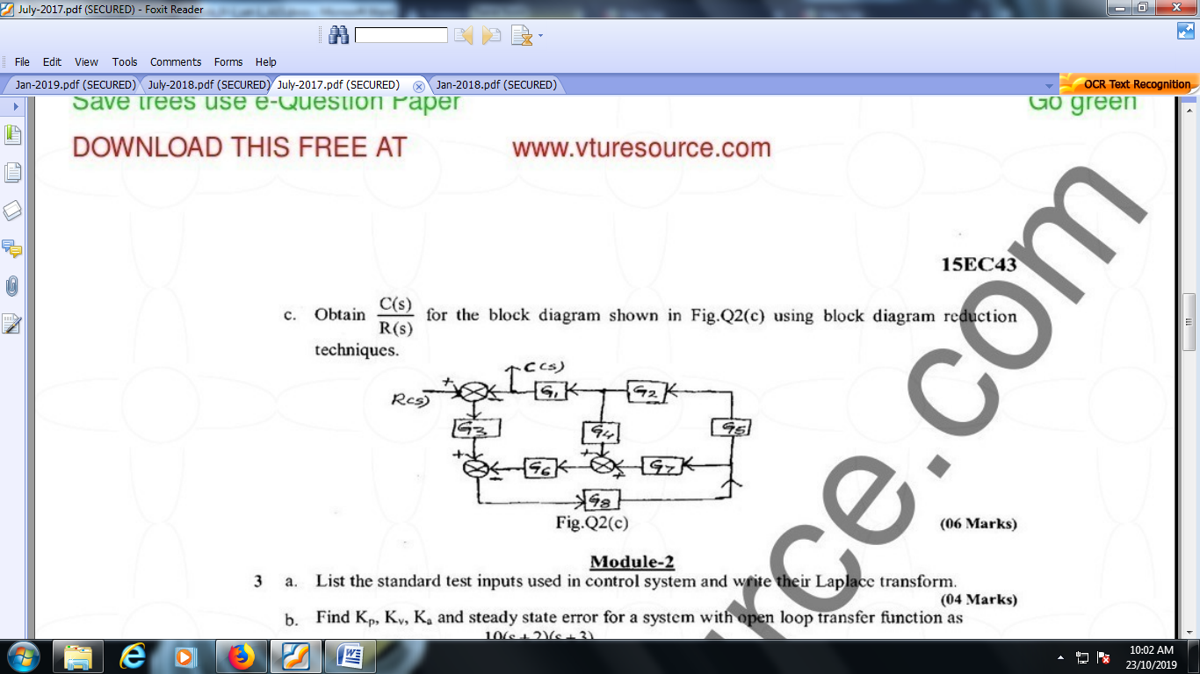 |  | CO1 | [7M]
2. | a) | Derive the expression for Peak time of a standard second order system. |  | CO2 | [7M]
 | b) | Find the rise time t_{r} and settling time t_{s} when the system is subject to a unit step input for the 2nd order control system, where ξ = 0.6 & Wn = 5 rad / sec. |  | CO2 | [7M]
3. | a) | State and Explain Routh-Hurwitz criterion. |  | CO3 | [7M]
 | b) | The open loop transfer function of a control system is given by  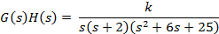  Sketch the complete root locus as ‘k’ is varied from zero to infinity. |  | CO3 | [7M]
4. | a) | Explain the frequency response specifications. |  | CO4 | [7M]
 | b) | Draw the Bode Plot for the system having  G(s) H(s) =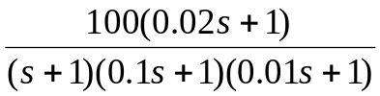.  Find gain and phase cross over frequency. |  | CO4 | [7M]
5. | a) | Write short notes on polar plots. |  | CO5 | [7M]
 | b) | State and Explain Nyquist stability criterion. |  | CO5 | [7M]
6. | a) | Find the state transition matrix for the system given by  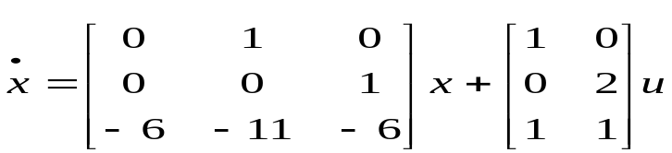 |  | CO6 | [7M]
 | b) |  |  | CO6 | [7M]
7. | a) | Explain the construction and working of a synchro. |  | CO1 | [5M]
 | b) | Show that with integral controller, the steady state error is zero for a ramp input. |  | CO2 | [5M]
 | c) | Determine the range of values of K for the stability of a unity feedback system  whose open loop transfer function is given by  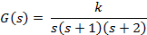 |  | CO3 | [4M]
8. | a) | Explain the procedure for finding transfer function from the Bode plots. |  | CO4 | [5M]
 | b) | Differentiate Lead-Lag compensation techniques. |  | CO5 | [5M]
 | c) | Explain the diagonalization with suitable matrix. |  | CO6 | [4M]
-- 00 -- 00 –

